# Restaurant and Home Service Robot

Vishal kumar raj(2019BEC33)

Central University of Karnataka

1st semester project

**Brief Introduction on Restaurant and Home Service Robot:**

Autonomous Robot is a type of robot which says that all robot which comes under this type are controlled by Human beings with help of some controller in example we can say via Bluetooth, wi-fi, and Rf transmitter etc.

The service robot is also count under this type and well controlled by some controller. In my project I also used one famous controller name Rf transmitter-receiver module. Basically, my project are commanded with the help of Arduino Uno. Components that I used in my project are:

1. Arduino Uno
2. L293d Motor driver
3. Rf transmitter-receiver module
4. 60 RPM Gear Motor
5. 3.5 RPM Gear Motor
6. 12-volt 5amp Battery

**Connection of my circuit**

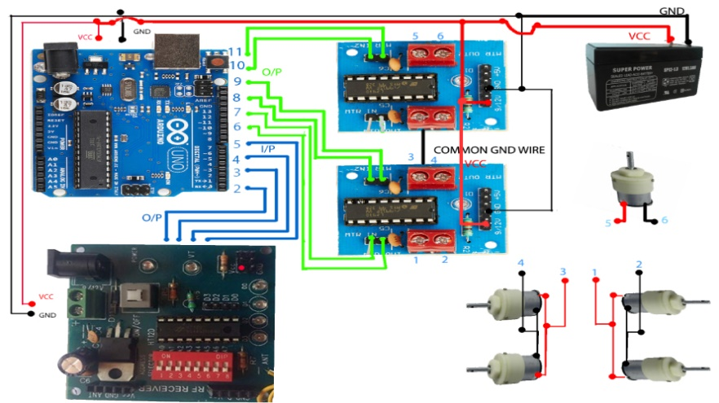

Logic of this connection is very simple while I have to use only one battery and give equal power to each and every component. In circuit diagram as we can see that I have taken 4 input and 6 output.

6 output are taken out by the motor drive to control the motors as an output. Using four output to control 4 motor of 60 rpm and other two for motor of 3.5 rpm.

6 output are taken out by the motor drive to control the motors as an output. Using four output to control 4 motor of 60 rpm and other two for motor of 3.5 rpm.

And other Input are taken out by the transmitter to control the movement of robot.